How to set up a git environment

# Step 1: Download git for windows

1. Download the git for windows from here: <https://gitforwindows.org/>
2. Install it (use the default settings if you’re not sure about anything)

# Step 2: Download TortoiseGit

1. Download from here: <https://tortoisegit.org/>
2. Install using default settings
3. If it asks you for name and email, you don’t have to enter any values that actually exust, they are never checked.

# Step 3: Clone a repository

1. Pick a Git repository (like, for example CoronaHakabModel at <https://github.com/CoronaHakab/CoronaHakabModel>)
2. Copy its address:

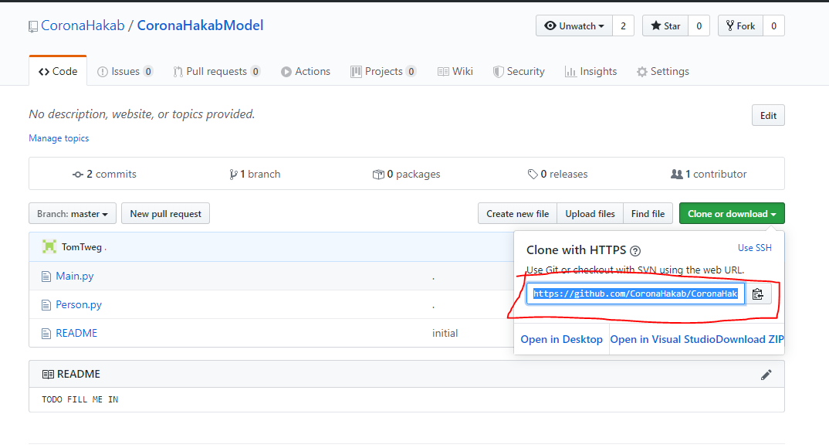

1. Pick or create a folder on your computer where to download the project.
2. Right click on an **empty space** in your folder and click on “Git Clone”

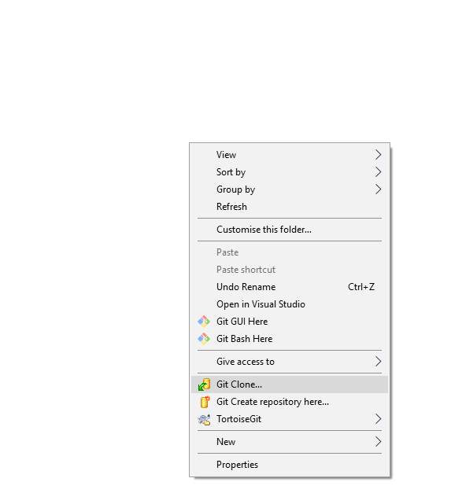

1. In the dialog box, paste in the link you copied in step 7, and click OK.

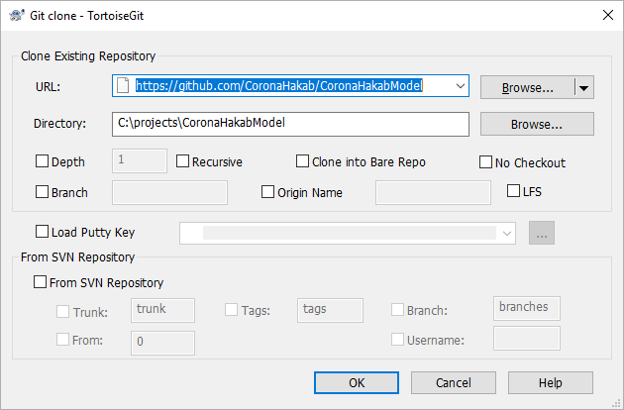

1. All the project’s files are now in that folder!

# Optional: Set up a Github profile

1. Go to <https://github.com/join?source=header-home>
2. Fill out the data to create an account
3. You can now join teams and contribute to projects

# Optional: Learn about Git

1. Git is a very powerful tool for coordinating software projects, it has many useful options and features, along thousands of courses and crash courses online, but the following is as concise a guide as I can manage.
2. A git repository is a collection of files, as well as its history of changes, across all its versions. Each repository has a remote location (and sometimes more than one). In our case, the remote location is online on a site called Github (other popular online git repositories are gitlab and bitbucket).
3. When you clone a repository to your computer, you literally copy al the files into your machine so you can work on it, even offline.
4. The following commands are the most common when working with git:
   1. Git Add: by default, git will ignore all new files it encounters in a folder, to add the file to the next commit and prepare it for uploading, right click it and click on tortoisegit->add.

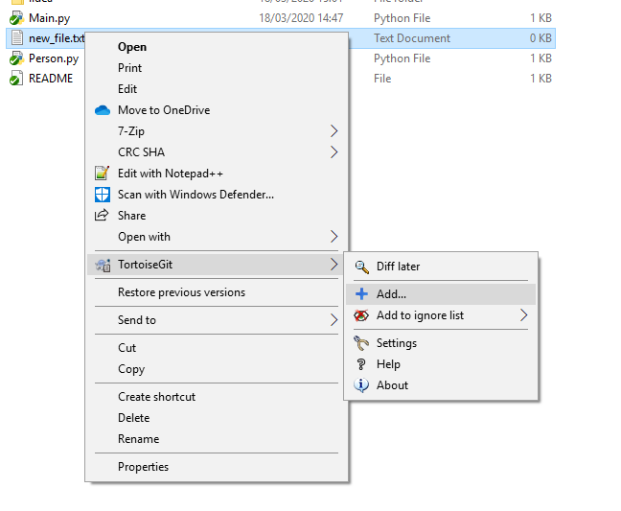

* 1. Git commit: once you add or change files in the directory, you will have to commit the changes locally before you can upload them. To do this, **right click in an empty space at the root directory** and click on git commit

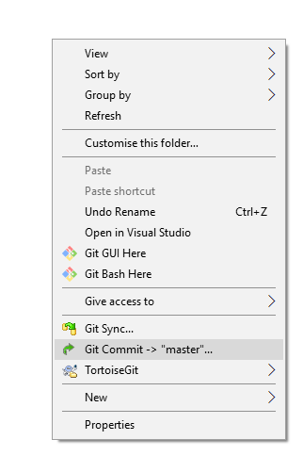

In the window that opens, you can review the changes you’ve performed and will have to set a commit message, to document what you’ve changed. It’s good practice to commit after every new feature or change.

* 1. Git push: Once you’ve committed a change you can push it to the remote repository and upload it. To do this, click on tortoisegit->push.

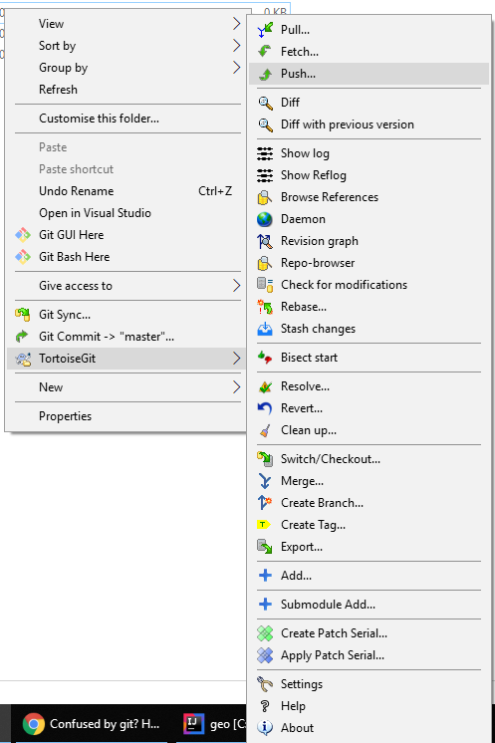

* 1. Git pull, to copy changes other users have pushed you will have to perform a git pull. 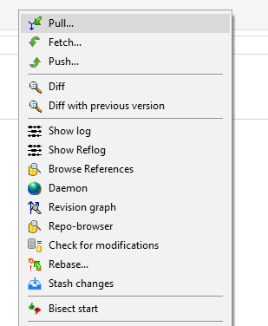

If another user has changed a file that you also changed, you will have to resolve the changes, chosing which lines to keep and which to replace. Tortoisegit makes this easy and intuitive.